# Control Test - Seminar 1

* **You must read the material in this document and answer questions and tasks with the examples of UML.**
* **You must process this document in team (2 students).**
* **This document is submitted by one member of team in the Moodle system (Control Test Submission Form).**

## Formal tasks

1. First, create a team for the project. Students must be divided into a groups (min. and max. count of students is 2 in a group.

**Please, fill name and surname of students in your team:**

Name of student 1: Mykhailo Kryhin

Name of student 2: Vladyslav Odynets

1. Each team will select the information system context for their team UML project implementation.

**What is topic of your project?**

Answer: Network of Libraries

## Review Questions

Answer the following questions. Write the answers directly to this document.

1. Who were the three lead authors of earlier notations who joined Rational Software Corporation to develop UML?

Answer: **Ivar Jacobson, James Rumbaugh, Grady Booch**

1. Which organization is now responsible for the UML standard?

Answer: **Object Management Group (OMG)**

1. Which of the following are abstractions
2. A map that you draw using just a few lines on a scrap of paper for friend to show the way to your home
3. A road atlas of London, England
4. London, England
5. A UML class diagram

Answer: **a, b, d**

1. Which of the following are models?
2. A UML class diagram
3. A set of UML class diagrams describing the classes in a software system
4. A 1:100 scale clay replica of a new sports car that will be used to test its aerodynamics in a wind tunnel
5. A full-scale, working prototype of a new sports car

Answer: **b, c, a**

1. Give three reasons for using UML.

Answer:

1. Visual Representation – allows us to easily understand program’s structure and relationships.
2. Standardization – it’s widely understood by developers.
3. Abstraction (Simplification) – when modeling a real app, we create a simplified model of it, which helps us to understand how it actually works.
4. What are the basic notational elements of class diagram?

Answer: Classes, relationships, class’s attributes and methods,

1. What are the purposes of drawing class diagrams?

Answer: To model a structure of an application which leads us to a better understanding of the application structure.

1. Define what is meant by a class.

Answer: A class is a group of objects with the same attributes and methods. In simple words: Class is a blueprint for an object.

1. What is the most basic notation for class?

Answer: attributes and methods (operations)

1. How can initial values for attributes be specified on a class diagram?

Answer: Like regular assignment operation in languages like Java or C#. See example below  
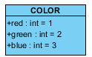

1. What is meant by multiplicity?

Answer: Multiplicity indicated the number of objects of one class that may be linked to a single object of an associated class. The example below we can read as “A company object has one or more instances of Employee objects”. Or in other words: “Company may have one or an infinite number of employees”  
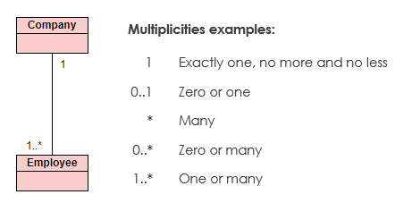

## Solve Problems

1. Here is part of a **class diagram** for banking system. *Explain this schema:*



Answer: A customer may hold any number of accounts. But each account can have only from 1 to 3 customers who hold it.

1. In the Insurance subsystem, car sharers can take out an insurance policy. Each insurance policy will be part of a particular insurance company’s scheme. What classes might there be here? ***Sketch out a first draft class diagram*** *(only classes and associations without attributes and operations).*

*Your diagram put in:*

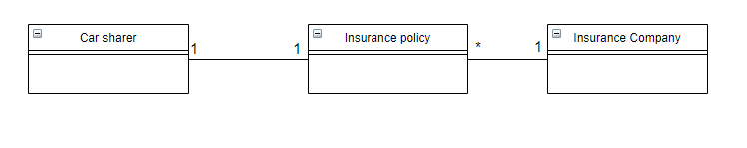

Assume that

* A car sharer can take out only one insurance policy
* An Insurance policy can be assigned to only one car sharer (like special offer).